
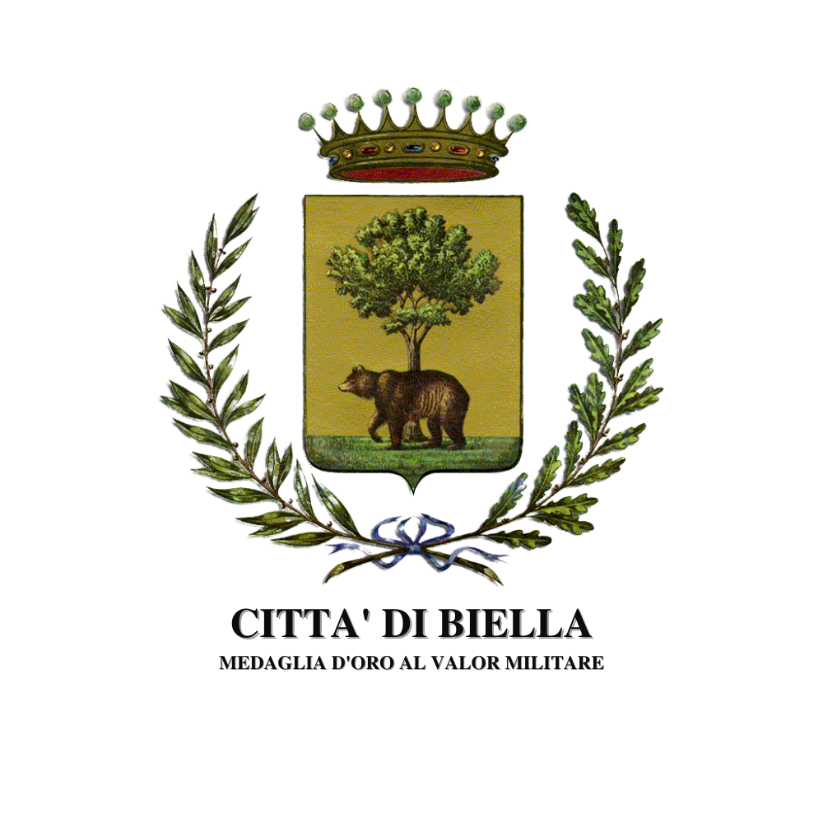


PRESS RELEASE

Andy WARHOL | Lorenzo PUGLISI
Sacred, Profane, Human

Biella,
Church of the Holy Shroud

31.10.25 - 01.03.26

(Biella, October 30, 2025) - On the occasion of the major exhibition, Warhol. Pop Art & Textiles, held at Palazzo Gromo Losa and Palazzo Ferrero in the historic village of Biella Piazzo, organized by the Fondazione Cassa di Risparmio di Biella, will open as a collateral event the exhibition
Andy Warhol | Lorenzo Puglisi - Sacred, Profane, Human at the Church of the Holy Shroud.

In this precious 17th-century church adjacent to the two buildings, Lorenzo Puglisi's work encounters the symbolic iconography of the father of Pop Art, in an inclusive contrast that evokes the different aspects of life: the Sacred, the Profane, and therefore, of course, the Human.

Three works: a painting of a woman by Puglisi, Portrait 270919 (previously exhibited at the 59th Venice Biennale in 2022) in the left niche of the exquisite nave, and,opposite, in the other niche, Warhol's famous Marilyn, the woman of the 20th century, Norma Jean - Marilyn Monroe: an eternal symbol of femininity, Pop-ularity, and sensuality, who, according to Marlene Dietrich, became the first true sex symbol of the 20th century and, following her premature death, a true icon of Pop culture.
In the center of the church, in the large marble frame of the altar of the Holy Shroud, a large painting by Puglisi, On the Mount of Olives, depicts a founding moment of human experience throughout time: the moment of doubt, the moment of a possible opening toward something other than oneself, toward the mystery of existence.

“This figure with open arms, in addition to welcoming the visitor, virtually embraces the other two female figures on display, including and blending contradictory aspects that characterize existence, the sacredness of the feminine, capable of generating life, and the profane, that which is earthly and mundane (from the Latin profanum, outside the temple) and which concerns the universal contradictions between spirit and matter, between high and low, not as opposing elements but as different and inseparable aspects of our lives,” - says Puglisi.

The exhibition is part of the major exhibition that the city of Biella is honored to host, featuring over 200 works, including silkscreens, photographs, ceramics, and, for the first time in Italy, original clothing, sketches, and fabrics by Andy Warhol, one of the great artists of the 20th century. The exhibition is organized by Palazzo Gromo Losa Srl, a subsidiary of the Fondazione Cassa di Risparmio di Biella and Creation, in collaboration with the Fashion and Textile Museum of London, the Municipality of Biella, Palazzo Ferrero Miscele Culturali, Associazione Stilelibero, Biella Città Creativa UNESCO, RJMA, Art Book Web, Beside Arts, and Promos (communications partner), with the support of the Banca di Asti Group.
Special thanks to Woolbridge Gallery and FAI for their support in organizing the event.

Andy Warhol, born Andrew Warhola Jr. (Pittsburgh, 1928 – New York, 1987), was an American painter, graphic designer, illustrator, film producer, director, cinematographer, and actor. He was a leading figure in the Pop Art movement and one of the most influential American artists of the 20th century. He died at the age of 58 following complications after surgery. In 1989, the Museum of Modern Art in New York dedicated a major retrospective to him. His influence on international visual and artistic culture continued to grow, and in the decades following his death, the fame and value of his works increased to the point of making Andy Warhol the second most bought and sold artist in the world after Pablo Picasso.

Lorenzo Puglisi (Biella, 1971) lives and works in Bologna. He has held numerous solo and group exhibitions in Italy and abroad, including at the CAC La Traverse in Paris (2015), The Historical Museum in Bremen (2017), King’s Cross St. Pancras Church in London (2019), the Kulhaus in Berlin (2019), Norman Foster’s Moore House (London 2020), the Marino Marini Museum in Florence (2021), and the 59th Venice Biennale (2022). On the 500th anniversary of Leonardo Da Vinci’s death (2019), he opened an exhibition in Santa Maria delle Grazie in Milan, and in 2020 he installed one of his paintings, Crucifixion, in front of Michelangelo’s wooden crucifixion in the Basilica of Santo Spirito in Florence. In 2021 he held an exhibition at the National Museum of Latvia in Riga in collaboration with the Uffizi Galleries who lent Tintoretto's Portrait of a Man; in 2022, he entered their collection with a self-portrait, exhibited among the 255 works (from 1400 to the present day) in the new exhibition inaugurated in 2023, featuring artists from Beato Angelico to Rembrandt, up to contemporaries as Pistoletto, Gormley, Bill Viola, and Ai Wewei. In 2024, he held shows with Aldo Mondino in Florence and Bologna curated by the Mondino Archive, and in 2025, he was invited to organize his first exhibition in the US at the Italian Cultural Institute in New York, meeting artists such as Julian Schnabel and Francesco Clemente. In 2025, he held a solo exhibition (over 50 paintings) at the Palazzo Ducale in Mantua.

The Church of the Holy Shroud was the first church of the Confraternity of the Holy Shroud, whose arduous construction work was completed around 1760, although it appears that the church had been used since 1676. After Napoleonic domination and the subsequent plundering of all its assets, it was purchased in 1834 by Marquis Carlo Ferrero Lamarmora. In 1841, the Church of the Holy Shroud became the headquarters of the company of young women belonging to the Daughters of Maria del Piazzo. In 1970, it was purchased by the famous printmaker, professor Sandro Maria Rosso, and has since been preserved and restored to all its beauty: the Rosso family, taking up the material and spiritual legacy entrusted to them, provided for the definitive restoration of the façade and interior in 2000, the Jubilee Year, with a design by architect Ippolito Calvi di Bergolo.

INFO

Andy Warhol | Lorenzo Puglisi. Sacred, Profane, Human
October 31, 2025 – March 1, 2026
Church of the Holy Shroud (Corso del Piazzo, 27 – Biella)

Press Conference: Auditorium of Palazzo Gromo Losa - Thursday, October 30, 2025, 6:00 PM

Opening: Thursday, October 30, 2025, 7:30 PM

Opening Hours: Friday, Saturday, Sunday - h 10.00 AM / 7.00 PM

Press Office
Exhibition "Andy Warhol | Lorenzo Puglisi. Sacred, Profane, Human"
Email: contact@woolbridgegallery.com
Cell: +39 347 8601965

CONTACTS
Lorenzo Puglisi
Email: lorenzopuglisi27@yahoo.it
Cell: +39 349 0072056

